Table of Contents

1 Table of Figures 1

2 Table of Tables 1

3 Table of Equations 2

4 Notes on Structure 1

5 Introduction and Outline 3

5.1 Aim of Thesis 3

5.2 Summary of Achievements 3

6 Background and Problem breakdown 4

6.1 Prior Art 4

6.2 Proximity as a solution 8

6.3 Controls 12

6.4 Proportional–Integral–Derivative controller 14

7 Scope 16

7.1 Proof of Concept 16

7.2 Variations 18

8 Functional Decomposition 20

9 Bibliography 23

# Table of Figures

Figure 1: Assisted-walking Device (Cybernetic Zoo, 2010) 4

Figure 2: G.E. Hardiman I Exoskeleton (Cybernetic Zoo, 2010) 5

Figure 3: Closed Loop Control System 12

Figure 4: Closed Loop Control System Block Diagram 12

Figure 5: Transfer Function 13

Figure 6: Controlled Closed Loop System 13

Figure 7: Controlled Closed Loop System (Parameterised) 13

Figure 8: P Control 14

Figure 9: PD Control 14

Figure 10: PID Control 15

Figure 11; System Decomposition 20

Figure 12: Point and Angle to Orientation 21

# Table of Tables

Table 1: Functional levels and associated movements 10

# Table of Equations

Equation 1: Transfer Function 13

Equation 2: Controlled Closed Loop Control System Transfer Function 14

Equation 3: PID Transfer Function 15

# Notes on Structure

The traditional thesis structure is broadly defined as:

* Introduction;
  + Background;
  + Scope; and,
  + Outline.
* Theory;
* Methods;
* Analysis;
* Discussion; and,
* Conclusions.

Due to the nature of the works competed in this thesis liberties were be taken to improve flow, clarity, and communication in general.

As per conventional structures, the project is introduced, and some background information relating to the context of the project is presented. From this the scope and focus of the thesis is derived and defined. Next the project is broken down functionally into the major subsystems required for a successful project (as defined in the scope).

Within each of these subsections standard structure is employed. The purpose and context of the subsystem is explained, and the requirements for practical completion are detailed. Then a literature review is conducted as appropriate for each subsystem, explaining technologies or theory as needed. From this the specific methods, in design and implementation are detailed for each subsystem, e.g. the engineered design, and then the specific technology employed to implement the design. Finally, analysis is conducted based on the outcomes of the subsystem.

The intention of this method is to allow for a consistent singular train of thought, where information on a system is presented sequentially, rather than all information relevant to the thesis presented in order of type.

Once the subsystems are discussed, the same process (scope, requirements, theory, method, and analysis) is applied to the task of integrated all the major subsystems into a single supersystem. This section details the complete system and the performance of the exoskeleton developed. This section presumes knowledge of the subsystems but does not demand knowledge of their intricacies. The intention is that by compartmentalising the details of the subsystems it is possible to discuss the design of the exoskeleton in general with brevity and clarity.

Finally, the results of the project are discussed, before the implications, recommendations, and conclusions of the project are discussed.

Readers primarily concerned with the outcomes of the proof of concept and thesis and not the specifics of how it was done, may find that reading **Error! Reference source not found.** and then skipping to **Error! Reference source not found.** (referencing the earlier sections of the documents as needed) is the most palatable method of consuming the document. Through this they may understand the projects context, what was done, and the results, without the dry technical details.

# Introduction and Outline

A powered exoskeleton, or exoskeleton, is wearable technology the amplifies and augments the pilot’s physicality. Through direct mechanical assistance via actuators, the pilot’s effective strength may be increased. By supplementing the strength required to complete a task the energy requirements of the task may be reduced; effectively increasing the pilot’s endurance. Possible uses for exoskeletons include: military operations, emergency & rescue, physical/manual labour, and medical applications.

Two major factors impact the viability of exoskeleton technology: power supply, and control. This thesis shall address one facet of the difficulties of exoskeleton control. Current exoskeleton control methods are inadequate due to mechanical constraints and the limitations of the control methods. Imperfections in mechanical design may result in a limited range of movement affecting the suits utility (e.g. A rigid spine in a confined space). Current methods of control use either force-based sensors or preprogramed movements. Finite sets of preprogramed movements are insufficient for dynamic environments (Charara, 2015). Force based methods encounter stability problems and may increase the exertion required to complete a task (Keller, 2016).

Instead this thesis will focus on the development of a novel power exoskeleton control method based on detecting the pilot’s position relative to the suit to maintain a constant offset; specifically focusing on the development of the controls and perception systems required to direct an exoskeleton.

An proximity-base control system, by maintaining a constant offset from the user, may exist as a concentric outline (or *bubble*) of the user, mirroring their actions. Thus, to control the system the pilot simply needs to assume the desired position of the suit, and the suit shall mimic them. By mimicking the user’s actions, the suit is more intuitive that force based and preprogramed methods. With no physical contact required to operate the system, the energy required from a pilot to complete a task with a load is effectively the same as completing the task with no load. Therefore, with any arbitrary load the user has the endurance to perform the task as if there no load at all.

Kt

## Aim of Thesis

## Summary of Achievements

# Background and Problem breakdown

## Prior Art

Exoskeleton technology began in 1890 (United States of America Patent No. 440684, 1890), with Nicholas Yagin’s development of a passive device that used compressed gas to assist in human movement, see Figure 1.

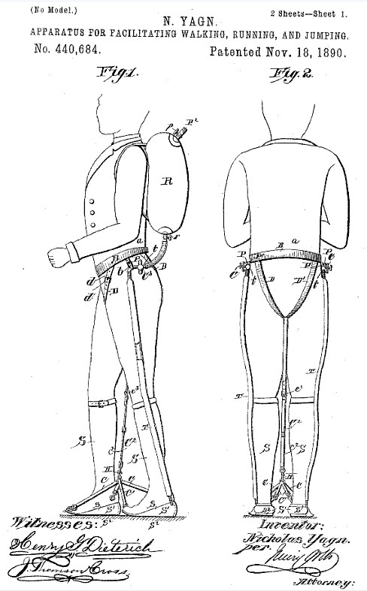

Figure 1: Assisted-walking Device (Cybernetic Zoo, 2010)

However, it was not until the 1960s that the first attempt at a practical powered exoskeleton was developed. The Hardiman (Keller, 2016) shown in Figure 2,created by General Electric, was ground-breaking but non-viable due to its extreme weight (double its maximum load) and control problems. The suit, when used as a complete system instead of in parts, was subject to dangerous violent uncontrolled movements and the master-slave control system suffered debilitating lag.

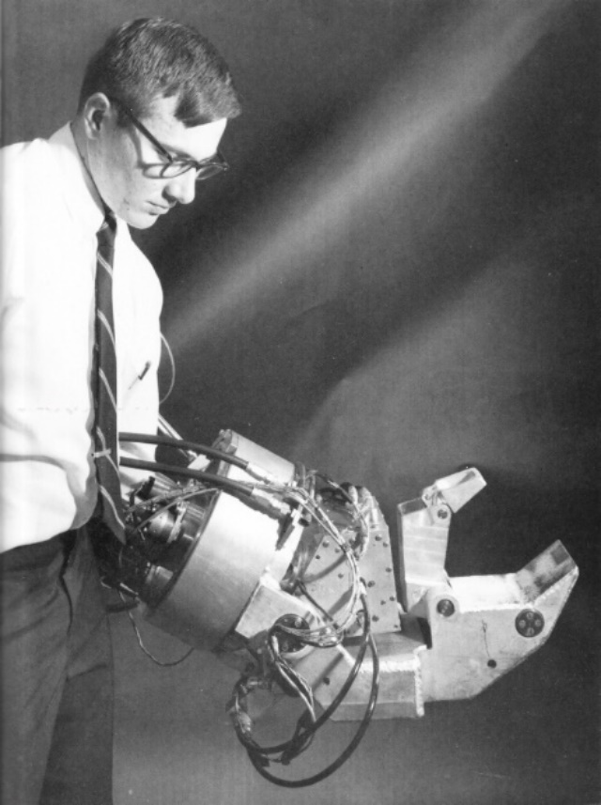

Figure 2: G.E. Hardiman I Exoskeleton (Cybernetic Zoo, 2010)

Prospective uses for exoskeletons usually involve a scenario where a human user may require the strength and endurance of a machine but wheeled vehicles are undesirable. Examples of possible applications include:

* Military Operations: operators are required to carry head loads over longs distances, lift large weights, and operate in dynamic and unruly conditions. Difficult terrain, heterodox environments, and general disarray result in heavy machinery often being unsuitable for certain circumstances. From urban to jungle operation exoskeletons provide possible utility.
* Rescue and evacuation missions: Rescue operations feature similar constraints to military operation with the additional concern of environmental hazards and structural collapse. In the event of a fire or chemical incident, the safety equipment and tools required can be large, heavy, and cumbersome; exoskeletons can alleviate some of this burden. Where structures are damaged or collapsed an exoskeleton can provide the extra strength required to save a life,
* Medical Systems: When amputation, age, or illness results in an individual suffering from reduced mobility and strength exoskeletons present exciting opportunities to compensate for their pilot’s impediments.
* Construction & Physical Labour: kt

These applications represent some of the broader uses for exoskeletons, neglecting the role of specifically designed exoskeletons for niche tasks: shock absorbing legs for parachutes/paratroopers, self-propelled underwater diving suits, etc.

Since the Hardiman, exoskeletons have been plagued by the same two major problems that have prevented their use in real world applications: power to weight ratio/power supply and control. The following outlines current developments in exoskeleton technologies.

### HULC

The Human Universal Load Carrier (HULC) is battery-powered lower extremity exoskeleton initially developed by Berkeley Robotics and Human Engineering Laboratory, before entering an exclusive licensing agreement with Lockheed Martin in 2009 (Axe, 2012). The system uses hydraulics to amplify the pilot’s knees and hips while supporting a load of up to 90kg. Designed for military applications it claims six hours of battery and uses force-based sensors for control.

The HULC was abandoned as” it proved impractical, exhausting users instead of supercharging them” (Cornwall, 2015) and has been succeeded by the TALOS project (Cornwall, 2015).

### EskoGT

In 2010 the original developer of the HULC, Esko Bionics revealed the Exoskeleton Lower Extremity Gait System (eLEGS) (Charara, 2015). With a maximum battery life of 6 hours and maximum gait of 3.2m/s (Charara, 2015), the system uses pushbuttons and force-motion sensors for control. Specially design for medical applications, the exoskeleton uses preprogramed movements to aid the mobility of stroke and spinal injury patients.

The suit is ill suited for dynamic environments as its finite range of movements prohibits uneven surfaces. While the suit may assist those with “upper extremity motor function of at least 4/5 in at least one arm” (Charara, 2015), the suit is slower than a wheelchair and is not an improvement on standard human movement.

### Raytheon XOS Exoskeleton

The 2008 Raytheon XOS Exoskeleton developed by Raytheon is a full body exoskeleton that can support up to 23kg on each arm (Karlin, 2011). The suit uses force-based sensors for control. Despite claims that the exoskeleton would be ready for production by 2016, they have made no public comments on progress since 2011 (Karlin, 2011).

### Warrior Web

The Warrior Web non-rigid exoskeleton was first demonstrated at the 2016 DARPA Demo Day (Cornwall, 2015). Developed by DARPA, it used preprogramed commands to assist with the user’s ankle motions. However, it was unpredictable in uneven terrain, malfunctioned, and could not transition readily between a walking and running state (Cornwall, 2015).

### Hybrid Assistive Limb (HAL)

In 1997 Cyberdyne unveiled the Hybrid Assistive Limb (HAL) (Cyberdyne, 2016). The HAL’s iterations include a battery-powered lower extremity exoskeleton and a full body exoskeleton (Cyberdyne, 2016). Through a combination of bioelectrical sensors and force sensors the HAL measured muscle contracts to trigger preprogramed movements.

The system has had mixed success, and despite applying for USA FDA approval in 2014, the HAL is yet to be permitted for use in the US (Cyberdyne, 2015).

### Preprogramed Control

Preprogramed control methods consist of a set of specific movements that are triggered in one way or another. HAL measures contractions in the arms of patients to trigger left-foot right-foot walking motions. Warrior Web applies torque to the ankle of the user (assisting them walk) when movement is detected.

These systems are inherently limited in their utility. By having a finite or procedurally generated set of movements there will always be scenarios or circumstances where the set of movements is not applicable. In real dynamic environments (e.g. military, rescue & evacuation, and physical labour) dynamic controls are required.

As noted by Dunietz when using an exoskeleton with preprogramed controls, the ”human does try to join in the motion, the two get in each other’s way, cancelling out the gains for all but the most extreme disabilities.” (Dunietz, 2017). Through this we seem the limited applicability of preprogramed movements; in circumstances where the movement of the pilot is so limited and restricted (e.g. via disability) that any system is an improvement. For an able-bodied pilot preprogramed movements are ”a bit like being a marionette with four wires controlling my legs” (Cornwall, 2015) and inadequate.

### Force Based Control

Force based control systems use force applied to the internals of a suit to determine the users desired position. The force applied indicates the direction and magnitude of movement. Force based systems are often inadequate for practical applications due to the sensitivity of force input. Systems which are too sensitive may develop jitter, and delays between sensing and movement combines with physical inertia may result in the system applying force to the user, creating an unstable feedback loop. Systems with are insensitive are slugging and require the pilot to push and move against the suit. Using these systems can be cumbersome and exhausting to use.

As the only mechanism for detecting position for a force-based system is the user making contact with the suit, misalignments in sizing can result physical dead bands when users are unable to touch the suit and the control system is effectively blind. Additionally, suits which maintain constant contact with asymmetrical body parts may interpret asymmetry as force input and therefore require constant active resistance from the user to control.

Finally, force-based systems do not distinguish between the force output of the system and the speed desired. If a user wishes to move quickly they must apply a large amount force to the system, if the suit encounters an obstacle this movement is then interpreted as a large amount of force applied to the object. There is no mechanism for quick safe movements.

For exoskeletons in dynamic real-world environments to be viable improvements on the existing force-based sensing methods are required.

## Proximity as a solution

Consider the following:

1. For controlling the suit, it may be assumed that the user is inside the suit during operation;
2. The users desired position for the suit may be treated as their position;
3. Thus, the positional error between the desired configuration of the suit and the actual configuration of the suit is the difference between the configuration of the pilot and the configuration of the exoskeleton;
4. If the position of the pilot relative to the suit is measured and known, then the position of the suit relative to the pilot can be known; and,
5. Therefore, the suit can be controlled accurately (that is to say, error can be known at any time) by observing the position of the pilot relative to the suit

It is proposed to develop a proof of concept for an positional exoskeleton control system (PECS) based on measurement of the pilot’s position/proximity the suit. By maintaining a constant offset from the user, the exoskeleton may exist as a concentric outline (or *bubble*) of the user, mirroring their actions.

Consider the following:

1. In a circumstance where the PECS encounters an obstacle it is desirable to regulate and control the force output of the system;
2. It is desirable to decouple the control of force output and speed (a noted flaw with force-based control methods);
3. To ensure safe movement that does not apply undue force to the environment, the force output of the PECS should be measured and regulated at external contact points.

It is proposed that for the PECS that the force output is directly measured (at contact points) to ensure safe and controlled operation.

Consider the following:

1. If the system applies force up to a safe maximum, then once that maximum is met then the PECS will stop matching pace with the user’s movement;
2. Under these circumstances the constant offset between the user and the system will not be maintained;
3. The user then may make contact with the internals of the PECS;
4. It is possible to use the pilot’s continuing attempts to towards the obstacle as intent to increase force output of the suit;
5. By measuring the force applied by the user to the inside of the PECS at contact points it may be possible for the user to indicate the desire for increased force output;
6. By measuring the force applied to external and internal contact points by the PECS and the pilot respectively it is possible for the PECS to operate with safe low force outputs which a pilot may override when increased force output is desired; and,
7. By using this system when the actuators are capable of strength beyond normal human capabilities, the pilot can effectively command and control superhuman strength in a safe and intuitive manner.

To properly control the force output of the system the forces applied internally and externally to the PECS shall be measured, and the force applied by the user to the internals of the PECS shall be used to control the force output of the systems actuators.

The subsequent system in summary:

* Uses position sensors to determine the desired configuration of the exoskeleton from the bodily configuration of the pilot;
* Uses external sensors to regulate the force output of the system, maintaining a safe maximum; and,
* Measures force applied internally to determine the force output of the system.

The potential benefits of such a system are summarised as follows.

##### Dynamic control

By mirror the movements of the user, with a sufficient mechanical design, the system is only limited by the capabilities of the pilot. Therefore, in any system which a human could navigate the system should be able to operate. Compared to preprogramed systems, it will be possible to navigate uneven terrain, switch contexts, and perform in unpredictable environments.

##### Intuitive control

The system described shall provide more intuitive control relative to other solutions. If the pilot seeks to move the left leg of the system, they must simply move their left leg. If the suit makes contact with an object the PECS will cease movement. If the pilot wishes to push the object, they simply need to push the object through the suit. The pilot may control the PECS as they would their own body.

#### Effortless operation

The system significantly increases the effective endurance of the pilot while requiring no exertion to use. Using the example of carrying a heavy load; for the user to walk normally requires a set amount of effort. With no load applied to the PECS the action should require the same amount of effort. With a sufficiently strong PECS, the system may be loaded with any arbitrary weight, but the effort required by th user to walk will remain unchanged. The PECS effectively gives the operator carrying a load the endurance of an operator with no load. Note, the magnitude of this benefit increases as the load increases.

### Functionality Requirements

To determine the viability of PECS and develop a proof of concept it is essential to define the required capabilities of such a system. The following outlines the requirements for a functional exoskeleton system:

1. The system must be capable of steady-state/static operation;
2. The system must be capable of dynamic and actuated operation;
3. The system must be capable of dynamic and actuated operation with non-regulated/imprecise force application;
4. The system must be capable of dynamic and actuated operation with regulated force application; and,
5. The system must be capable of dynamic and actuated operation with regulated force application under real-time conditions.

Should the system be capable of achieving level 5 operation it can be said to be fully functional. To assess the system’s level of functionality specific test case are required which may be considered representative movements of the requirements of each level of functionality. These are outlined as follows in Table 1.

Table 1: Functional levels and associated movements

|  |  |  |  |  |  |
| --- | --- | --- | --- | --- | --- |
| Functionality Level | Representative Movement | Position of Pilot | Position of Exoskeleton | Force Applied by Pilot | Force Applied by Exoskeleton |
| L1 | Standing | **🗸** | **🗸** |  |  |
| L2 | Squatting | **🗸** | **🗸** |  |  |
| L3 | Stairs | **🗸** | **🗸** |  |  |
| L4 | Sitting | **🗸** | **🗸** | **🗸** | **🗸** |
| L5 | Sprinting | **🗸** | **🗸** | **🗸** | **🗸** |

As seen in Table 1, there are four main pieces of information required to control the PECS at all levels. From the required information it is possible to create a system that can demonstrate all levels of functionality. Note that every representative movement can be completed using only the lower extremities. This implies that to develop a proof of concept for PECS only a lower extremity exoskeleton would be required.

## Controls

“A control system is an interconnection of components forming a system configuration that will provide a desired system response.” (Ogata, 2010).

A closed loop control system uses feedback and measurements to compare the system with the desired output. By modelling a system and developing the appropriate controls system we may generate the desired behaviour from the system.

A closed loop control system, see Figure 3, can be summarised as the interaction of (Ogata, 2010):

* Controllers: which are instructed as to the desired behaviour while receiving feedback from sensors on the actual behaviour of the system;
* Actuators: which modulate their behaviour based on instructions from the controllers;
* A process to be controlled; and,
* Sensors: which measure the behaviour of the system (the actual output of the process) and inform the controllers.

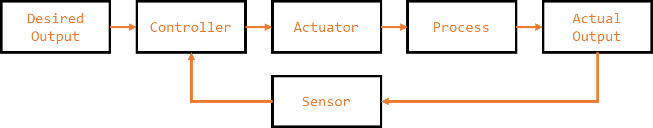

Figure 3: Closed Loop Control System

One method of conceptualizing the behaviour of a system is to create block diagrams of the system (Golnaraghi & Kuo, 2010). Block diagrams may be used to communicate comparators, transfer function components, input and output signal, feedback loops, etc. We may describe the state of a closed loop system via block diagrams, see Figure 4.

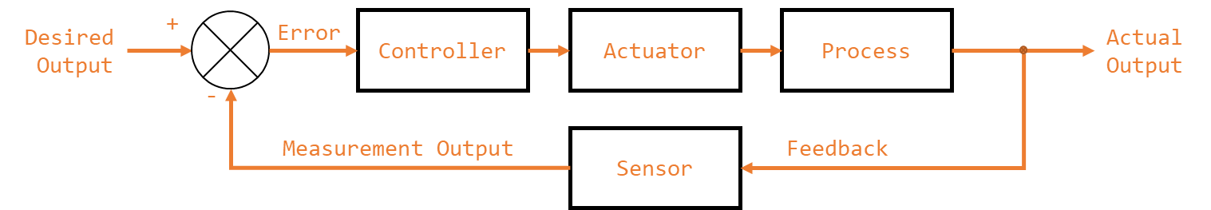

Figure 4: Closed Loop Control System Block Diagram

Here the error of the system is the difference between the desired state and the measured state. The (usual) goal of controls is to reduce the error to zero. This may be accomplished by numerous methods, which include the transfer function method.

### Transfer Function Approach to Modelling and Control

“The transfer function of a linear, time-invariant differential-equation system is defined as the ratio of the Laplace transform of the output (response function) to the Laplace transform of the input (driving function) under the assumption that all initial conditions are zero.” (Otaga, 2004)

We may define the transfer function, for a system as given by Equation 1; where is the Laplace transform of the input and is the laplace transform of the output. This may be seen diagrammatically in Figure 5. The transfer functions allows us to map from a set of inputs to the outputs of asystem.

Equation : Transfer Function

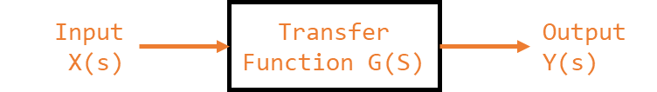

Figure : Transfer Function

For a closed loop system we may say that the behaviour of the system, as seen in Figure 6, may be described by the relationship of the control system and the system process with respect to the error (Golnaraghi & Kuo, 2010).

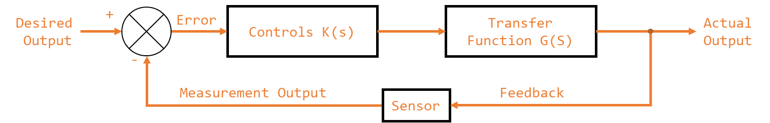

Figure : Controlled Closed Loop System

We may minimise the error of the system by correctly curating the control system (K). This is to say, given a system described by G(s), by controlling K(s) (the controllers and actuators) we can ensure that the actual output of the system is the desired output of the system (Otaga, 2004). The transfer function for this system, based on the block diagram in Figure 7, is given by Equation 2.

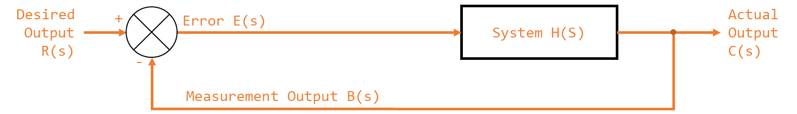

Figure : Controlled Closed Loop System (Parameterised)

Equation : Controlled Closed Loop Control System Transfer Function

## Proportional–Integral–Derivative controller

A proportional–integral–derivative controller (PID) is a method of developing the controls parameters (and K(s)) for a system.

One approach to controls is to simply amplify the actuators response proportionally to the error. This is known as proportional control and is shown in Figure 8.

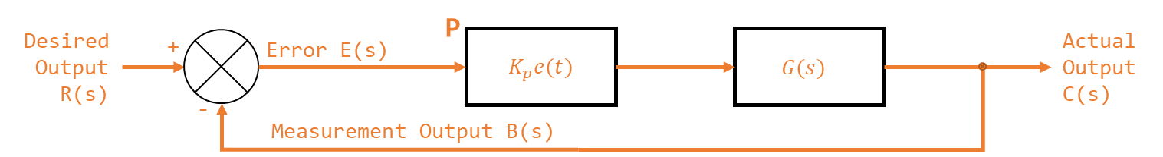

Figure : P Control

If the proportional gain of a system is too small the response time of the system may be too slow. If the value is to high the system may overcompensate, resulting in oscillations and overshooting the target values. If the proportional gain is sufficiently high the system may oscillate so wildly that it becomes unstable (Otaga, 2004). Unstable meaning the system never reaches the desired output and the error of the system increases over time. (National Instruments, 2018).

Proportional is effective at addressing the large present error in the system. To create a fast response time for a system, without increasing the proportional gain to unstable values often a derivative term is employed.

Figure 9: PD Control depicts a system with a proportional () and a derivative gain (). changes in response to the rate at which error is changing. By incorporating a proper value the system can effective pre-empt change in error, leading to a faster response time (Ogata, 2010).

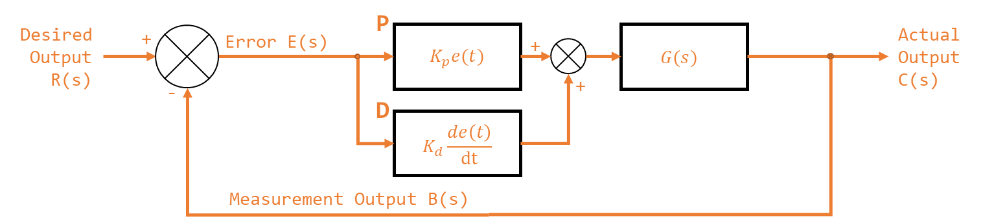

Figure : PD Control

A value that is too low will result in a system that doesn’t react strongly to changes in error. A value that is correctly calibrated will result in a system that reacts strongly to sudden changes in the system. A value that is too high will reacts too strongly to changes in error and will become highly sensitive to signal noise. Small changes in absolute error which would be ignored by the proportional term may illicit an unwarranted response from an overly sensitive .

For small errors the proportional gain may be insufficient for correction and increasing the proportional gain may result in instability. For constant small errors the change in error may be too small for the derivative gain to correct and increasing the derivative gain may result in instability. Small persistent error in the system, otherwise known as steady state error, may exist in a system with pure PD control.

To compensate and correct the steady state error in a system an integral gain term may be introduced. A system with an integral gain may be seen in Figure 10. The integral gain in practical terms accumulates historical error in the system. This way, even small errors can slowly increase the integral term to an actionable magnitude.

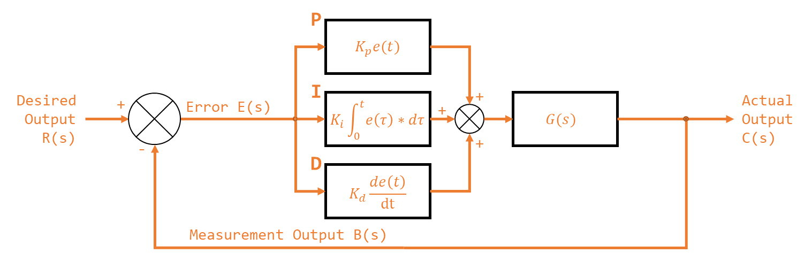

Figure : PID Control

An integral gain that is too small will take a very long to correct steady state error within the system. An integral gain that is too large will suffer from integral windup, specifically excessive overshooting the target value. Integral windup is phenomena where a sudden and large change in error cause the integral term to accumulate a massive error that saturates the entire PID response leading to overcompensations. An integral gain that is too large may result in integral wind up of sufficient magnitude that the system becomes unstable.

The transfer function for a PID controller is given by Equation 3.

Equation : PID Transfer Function

# Scope

## Proof of Concept

The purpose of this thesis is to develop some of the major subsystems for a proof concept for a position-based exoskeleton control system. As noted above in 6.2.2, to create a proof of concept for the system only a lower extremity exoskeleton is required.

### Task Division

Creating said proof of concept however, is beyond the scale and scope of a single undergraduate thesis. Instead, the task was to be divided amongst two students, who would complete subsystems independently before integrating their work. It was eventually determined that the most elegant and functional demarcation of tasks would be to divide the system according to determining the required actions and performing the required actions. As such one student would be responsible for determining the required action from the exoskeleton systems to perform as desired, and one student would create a system that was capable of performing said actions. Broadly speaking, one student would design and create the sensing/perceiving and control systems for the proof of concept, and the other would create the structural and actuation systems of the proof of concept. The point of integration between the two systems would be a communication system capable of transmitting the desired action from one side to the other.

This student, Samuel Williams, was assigned the perception and control systems.

As a matter of clarification, it is important to note that the terms: actuation system, control system, perception system, and structural system are descriptive terms for the approximate scope and manner of certain groups of subsystems. They are not prescriptive and should not be treated as such, e.g. the mechanical structure required to hold the force sensors in place is structural but is within the scope of the perception systems not the structural system.

### Required Systems

A full functional decomposition can be found in 8.

Based on the specific division of tasks and the demarcation devised the following major functional requirements where identified.

1. Detection of Pilots position relative to the exoskeleton (detection of the suit’s absolute position would be the responsibility of the actuation system)
2. Force application of the exoskeleton to the environment and the pilot to the exoskeleton
3. Control system for determining required action (torque) from actuation system for correct operation
4. Communication from control & perception software to actuation system

### Inclusions (In Scope)

The commissioning of the following was considered within the of scope and the project:

* A lower extremity exoskeleton;
  + This includes feet, shins, thighs, and waist.
* Systems required to perceive the position of an exoskeleton pilot relative to the exoskeleton;
  + This includes the hardware, firmware, software, and mechanical structure required.
  + This is limited to detection of the position of the femur, tibia, and foot (treated as a singular entity). This does not include the detection of the position of individual toes or the internal actuation of the foot.
* Systems required to perceive the force applied by an exoskeleton pilot to an exoskeleton;
  + This includes the hardware, firmware, software, and mechanical structure required.
  + This is limited to the detection of force application at the soles of the feet and the rear of the pilot, zones required for the representative movements.
  + This is limited to a rigid sole without actuation, i.e. the foot may move and bend at the ankle but shall not be treated as flexing at the ball of the foot.
* Systems required to perceive the force applied by exoskeleton its environment;
  + This includes the hardware, firmware, software, and mechanical structure required.
  + This is limited to the detection of force application at the soles of the feet and the rear of the pilot, zones required for the representative movements.
  + This is limited to a rigid sole without actuation, i.e. the foot may move and bend at the ankle but shall not be treated as flexing at the ball of the foot.
* Controls theory required to determine the desired position of the exoskeleton; and,
  + This is limited to determining the desired torque and angle of the actuation systems.
  + This does not include determining power, voltage, or current requirements for actuators.
  + This does not include determining control inputs (e.g. pulse width modulation duty cycles) for the actuation systems.
* Communication systems required to relay system readings and desired actions between actuation system and controls system.
  + This is limited to creating an input and output connection for interfacing with the actuation & structural system via a common protocol.
  + This does not include the implementation of a communication protocol for the student responsible for the actuation & structural systems.

### Exclusions (Out of Scope)

The following tasks were considered out of scope and where excluded from the project:

* Commissioning of the torso, head, or upper extremities of an exoskeleton;
* Commissioning of actuation and structural systems required to support and actuate a lower extremity exoskeleton;
* Measurement of actuator positions or absolute exoskeleton position;
* Measurement of velocity, acceleration, or torque of any section of the exoskeleton;
* The development of an exoskeleton capable of supporting additional loads, i.e. carrying weights beyond those required for demonstration of proof of concept;
* There was no compensation for the flexion and distortion of body parts, e.g feet;
* Addressing power consumption problems, power-to-weight ratio problems, or price problems associated with exoskeletons;
* Actuation points (hip, knee, ankle) where constrained to 1 degree of freedom (DOF); and,
* Anything not in scope.

## Variations

The original proposed scope did not include the creation or design of any actuations, or the interfacing between the control and perceptions systems and the systems actuators. As the project progressed it became apparent that the mechanical/actuation section of the project would not be completed in time for proper operation and that to properly develop and demonstrate the functionality of the controls and perception system a testing rig would be required. As such, the original scope of the project was extended to include the design and create of a simplified actuation system capable of refining, testing, tuning, and demonstrating the controls and actuation systems.

Consequentially, a fifth major function requirement was added to the system:

1. Development of actuation system sufficient to demonstrate attainment of other major function requirements.

### Inclusions (In Scope)

The following was considered within the of scope and the project:

* Commissioning of actuators and mechanical structure required to demonstrate functionality of position detection systems;
* Commissioning of actuators and mechanical structure required to demonstrate functionality of force detection systems;
* Development of motor interface and power systems required to control actuators in the desired fashion.

No new exclusions were added to the project.

# Functional Decomposition

The system defined by the scope, see 7, was decomposed into its major function requirements as seen in 7.1.2. Functional decompositions were then completed for the major subsystems in their respective sections (see **Error! Reference source not found.**, **Error! Reference source not found.**, **Error! Reference source not found.**, **Error! Reference source not found.**, and **Error! Reference source not found.**). This section outlines that major function requirements of the system.

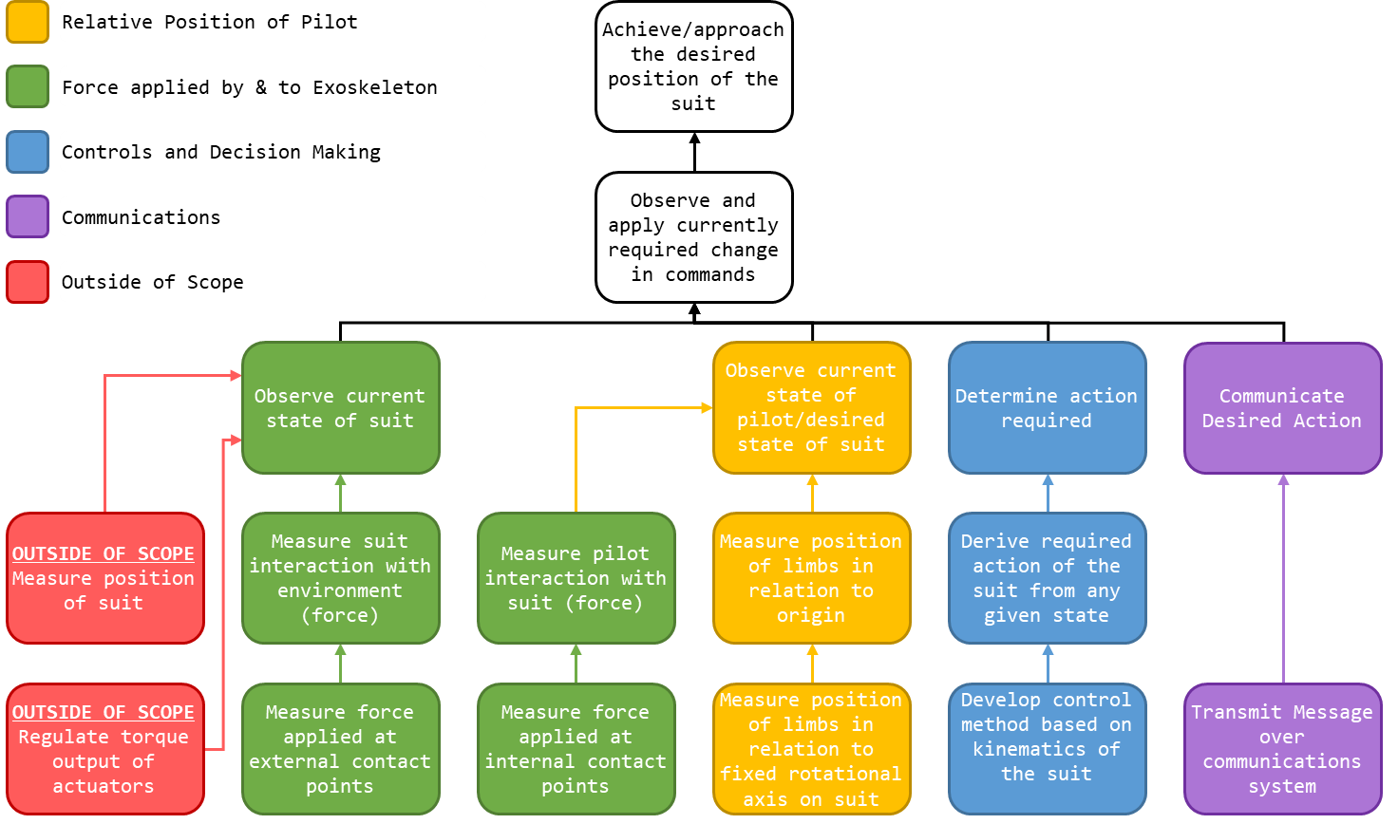

Figure 11; System Decomposition

As seen in Figure 11; System Decomposition, he ultimate goal of the project is that all times the lower extremity exoskeleton will be in the desired position. This may be accomplished by constantly observing the differences between the current state of the system and the desired state of the system and then changing the current system accordingly.

To observe the desired state of the system the position of the pilot and the force applied by the pilot to the exoskeleton must be known.

As seen in Figure 12: Point and Angle to Orientation, the position of a straight linear rod of a fixed length can be described by the relation of a point on the rod (as an angle) to a fixed rotational axis and origin. By observing the angle of a rod relative to an axis we can know the orientation of said rod. Therefore, to determine the current state of the pilot it is possible to observe the location of each limb segment (treated as a straight rod) in relation to a fixed rotation axis.

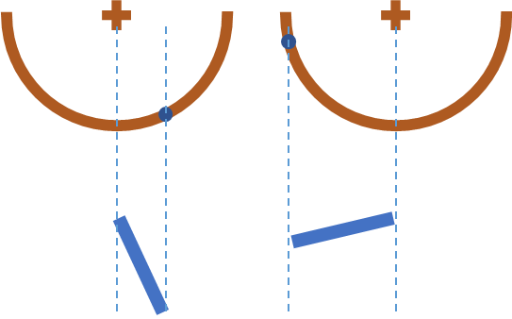

Figure 12: Point and Angle to Orientation

If the rotational axis of the actuation points of the exoskeleton alight with the rotation axis of each limb segment (assuming the hip, knee, and ankle may be treated as 1 DOF hinges) then the position of each limb in relation to the actuation point may be used to determine the position of each limb. By observing the position of the pilot’s limbs in relation to the suit, it is possible to know where the pilot is positioned (assuming the position of the suit is known).

As stated in 6.2, the pilot may apply force to the internals of the exoskeleton to indicate the desire to increase the force output of the suit. As a result, the force applied to the internals of the suit must be measured. For the representative motions required for a proof of concept; contact is only required with the ground and a seat, therefore the only locations where force output is required is the rear and the soles of the feet. Only knowledge of the force applied to the internals of the suit at contact points is required to maintain control.

By observing the actual state of the exoskeleton, it is possible to determine the changes required to approach the desired configuration of the exoskeleton. The force/torque output of the actuators of the system is consider out of scope, and the position of the actuators and the absolute position of the suit is considered out of scope. However, the force applied by the system to its environments is within scope and must be determined to identify if force output of the exoskeleton should be changed.

For the representative motions required for a proof of concept; contact is only required with the ground and a seat, therefore the only locations where force output is required is the rear and the soles of the feet. Only knowledge of the force applied to the externals of the suit at contact points is required to maintain control.

In order to determine the action required of the system once the state of the pilot and the state of the exoskeleton are known the kinematics of the suit and the system response in a given state must be known.

To communicate between devices and between the actuation and perception/controls systems it is necessary to transmit messages in a predefined format.

# Bibliography

Agarwal, A. (2005). *Foundations of analog & digital electronic circuits* (1 ed.). Massachusetts: Massachusetts Institute of Technology. Retrieved June 1, 2018, from https://www.google.com/url?sa=t&rct=j&q=&esrc=s&source=web&cd=1&ved=0ahUKEwiBu7yQl7LbAhUEoZQKHfYlBzkQFggpMAA&url=http%3A%2F%2Fsiva.bgk.uni-obuda.hu%2Fjegyzetek%2FMechatronikai_alapismeretek%2FEnglish_Mechatr%2FElectr_Eng-1%2FLiterature%2FFoundations%2520o

American Technologies Network Corporation. (2018, May 30). *How Does Night Vision Work*. Retrieved from atncorp.com: https://www.atncorp.com/hownightvisionworks

Arrow. (2018). *Magnetoresistive Sensor.* Retrieved May 30, 2018, from arrow.com: https://www.arrow.com/en/categories/sensors/magnetoresistive-sensors

Axe, D. (2012, May 23). *Combat Exoskeleton Marches Toward Afghanistan Deployment*. Retrieved May 30, 2018, from Wired: https://www.wired.com/2012/05/combat-exoskeleton-afghanistan/

Bulgrin, M. (2017, May 11). *The History of the Hose Clamp.* Retrieved from normagroup.com: https://blog.normagroup.com/en/the-history-of-the-hose-clamp/

Bunnings. (2018, May 31). *Kinetic 21 - 44mm 304 Stainless Steel Hose Clamp.* Retrieved May 31, 2018, from Bunnings.com: https://www.bunnings.com.au/kinetic-21-44mm-304-stainless-steel-hose-clamp_p4920194

Charara, S. (2015, July 9). *This robotic exoskeleton helps paralysed patients to walk and it's getting smarter*. Retrieved August 23, 2017, from Wearable: https://www.wareable.com/wearable-tech/exoskeleton-paralysed-patients-ekso-bionics-gt-sarah-thomas

Computer Cable Store. (2018, May 31). *11 7/8 Inch Black Standard Nylon Cable Tie - 100 Pack.* Retrieved May 31, 2018, from computercablestore.com: https://www.computercablestore.com/11-78-inch-black-standard-nylon-cable-tie-100-pack

Cornwall, W. (2015, October 15). *Feature: Can we build an ‘Iron Man’ suit that gives soldiers a robotic boost?* Retrieved August 20, 2017, from sciencemag.org: http://www.sciencemag.org/news/2015/10/feature-can-we-build-iron-man-suit-gives-soldiers-robotic-boost

Cracknell, A. P., & Hayes, L. (2007). *Introduction to Remote Sensing* (2 ed.). London: Taylor and Francis. Retrieved May 30, 2018

Cutnell, J. D., & Johnson, K. W. (1998). *Physics* (4th ed.). New York: Wiley.

Cyberdyne. (2015, August 1). *CYBERDYNE Inc. has begun seeking approval from the U. S. Food and Drug Administration (FDA)*. Retrieved August 23, 2017, from cyberdyne.jp: https://www.cyberdyne.jp/english/company/PressReleases_detail.html?id=1075

Cyberdyne. (2016). *What’s HAL?* Retrieved August 19, 2017, from cyberdyne.jp: https://www.cyberdyne.jp/english/products/HAL/

Cybernetic Zoo. (2010, October 14). *1890 – Assisted-walking Device – Nicholas Yagn (Russian)*. Retrieved May 30, 2018, from Cyberneticzoo.com: http://cyberneticzoo.com/tag/nicholas-yagn/

Cybernetic Zoo. (2010, April 10). *1965-71 – G.E. Hardiman I Exoskeleton – Ralph Mosher (American)*. Retrieved May 30, 2018, from cyberneticzoo.com: http://cyberneticzoo.com/man-amplifiers/1966-69-g-e-hardiman-i-ralph-mosher-american/

Dawkins, P. (2018). *Differential Equations - Notes - Laplace’s Equation*. Retrieved June 3, 2018, from Paul's Online Math Notes: http://tutorial.math.lamar.edu/Classes/DE/LaplacesEqn.aspx

Dunietz, J. (2017, July 27). *Robotic Exoskeleton Adapts While It’s Worn*. Retrieved August 20, 2017, from scientificamerican.com: https://www.scientificamerican.com/article/robotic-exoskeleton-ldquo-evolves-rdquo-while-its-worn/

Future Electronics. (2018, May 30). *What is Optoelectronics?* Retrieved from Future Electronics: http://www.futureelectronics.com/en/optoelectronics/infrared-receivers.aspx

Garbett, I. (2001, Janurary 1). *Light attenuation and exponential laws*. Retrieved May 30, 2018, from plus.maths.org: https://plus.maths.org/content/light-attenuation-and-exponential-laws

Golnaraghi, F., & Kuo, B. C. (2010). *Automatic Control Systems* (9 ed.). Hoboken: John Wiley & Sons, Inc. Retrieved June 4, 2018

Gross, K. (2018, Feburary 19). *Ultrasonic Sensors: Advantages and Limitations*. Retrieved May 30, 2018, from MaxBotix: https://www.maxbotix.com/articles/advantages-limitations-ultrasonic-sensors.htm/

Jackson, R., Green, K. R., & Eisenbeis, R. (2017). *Achieve greater precision, reliability with integrated magnetic sensing technology.* Retrieved May 30, 2018, from ti.com: http://www.ti.com/general/docs/lit/getliterature.tsp?baseLiteratureNumber=sszy030&fileType=pdf

Karlin, S. (2011, July 29). *Raytheon Sarcos’s Exoskeleton Nears Production*. Retrieved August 11, 2017, from spectrum.ieee.org: http://spectrum.ieee.org/at-work/innovation/raytheon-sarcoss-exoskeleton-nears-produc

Keller, M. (2016, August 25). *Exoskeleton - Do You Even Lift, Bro? Hardiman Was GE’s Muscular Take On The Human-Machine Interface*. (General Electric) Retrieved May 30, 2018, from GE Reports: https://www.ge.com/reports/do-you-even-lift-bro-hardiman-and-the-human-machine-interface/

Keyence Corporation. (2018). *What is a Inductive Proximity Sensor?* Retrieved May 30, 2018, from keyence.com: https://www.keyence.com/ss/products/sensor/sensorbasics/proximity/info/

Khatib, O. (2008). Chapter 5 - Dynamics. In O. Khatib, *Introduction to Robotics* (pp. 125-150). Stanford: Stanford University.

Liew, S. C. (2018, May 30). *Electromagnetic Waves*. Retrieved from Centre for Remote Imaging, Sensing and Processing.: https://crisp.nus.edu.sg/~research/tutorial/em.htm

Lynch, D. K., & Livingston, W. C. (2001). *Color and Light in Nature* (2nd ed.). Cambridge, United Kingdom: Cambridge University Press. Retrieved May 30, 2018, from https://books.google.com.au/books?id=4Abp5FdhskAC&pg=PA231&redir_esc=y#v=onepage&q&f=false

Merriam-Webster Dictionary. (2018, May 18). *noise*. Retrieved May 30, 2018, from merriam-webster.com: https://www.merriam-webster.com/dictionary/noise

National Instruments. (2018). *PID Theory Explained.* Retrieved June 4, 2018, from NationalInstruments.com: http://www.ni.com/white-paper/3782/en/

Ogata, K. (2010). *Modern Control Engineering* (2 ed.). New Jersey, United States of America: Prentice Hall. Retrieved August 25, 2017

Otaga, K. (2004). *System Dynamics* (4 ed.). Upper Saddle River: Pearson. Retrieved June 4, 2018

Robomart. (2015, November 9). *Advantages and Disadvantages of ultrasonic distance sensor.* Retrieved May 30, 2018, from Robomart: http://roboticsensors.blogspot.com/2015/11/advantages-and-disadvantages-of.html

Siciliano, B., & Khatib, O. (2016). *Springer Handbook of Robotics* (2 ed.). (B. Siciliano, & O. Khatib, Eds.) Berlin: Springer Nature. doi:10.1007/978-3-319-32552-1

Texas Instruments Incorporated. (2017). *Hall effect sensors*. Retrieved May 30, 2018, from ti.com: http://www.ti.com/sensing-products/magnetic-sensors/hall-effect/overview.html

Thomas Publishing Company. (2018). *Capacitive Proximity Sensors*. Retrieved May 30, 2018, from Thomas: https://www.thomasnet.com/articles/instruments-controls/proximity-sensors

Vishay Semiconductors. (2017, February 8). TCRT5000 - Reflective Optical Sensor with Transistor Output.

Yagin, N. (1890, February 11). *United States of America Patent No. 440684.*

Yuhas, D. (2012, May 24). *Speedy Science: How Fast Can You React?* Retrieved from scientificamerican.com: https://www.scientificamerican.com/article/bring-science-home-reaction-time/

ZJIA. (2018, June 1). *Generic YZC-161B 50kg Body Scale Sensor Human Scale Weighing Load Cell Sensor (Pack of 4)* . Retrieved June 1, 2018, from Amazon.com: https://www.amazon.com/Generic-YZC-161B-Scale-Sensor-Weighing/dp/B00MTJ6WZ2